Target Multiplier
Write a program which reads from the console dimensions of a matrix and matrix elements values. Get a targeted cell and multiply its value with the sum of all neighboring cells. The neighboring cells must change their values too. Each one should be the product of its initial value and the initial value of the targeted cell. Then print on the console updated matrix.
Input
The input data should be read from the console:
The first line holds the number of rows – R and columns – C, separated by space.
The next R lines hold the matrix values. Each line holds C integers, separated by space.
The last line holds the position (targeted row and targeted col) of the targeted cell, separated by space
The input data will always be valid and in the format described. There is no need to check it explicitly.
Output
The output should be printed on the console. The elements of each row should be separated by space.
Constraints
The dimensions of the matrix (R and C) will be a positive integer numbers in the range [3...20].
The values of the cells will be an integer numbers in range [-16,300... 16,300].
The targeted row will be an integer number in the range [1...R-2].
The targeted column will be an integer number in the range [1...C-2].
Examples
Input | Output | Comments
5 5  10 12 14 16 17  10 12 14 16 17  10 12 14 16 17  10 12 14 16 17  10 12 14 16 17  2 2 | 10 12 14 16 17  10 168 196 224 17  10 168 1568 224 17  10 168 196 224 17  10 12 14 16 17 | Targeted cell is [2,2] = 14  The sum all neighboring cells is:  12 + 14 + 16 + 12 + 16 + 12 + 14 + 16 = 112  The targeted cell new value = 14 * 112 = 1568  Neighboring cells new values:  [1,1]=12*14=168; [1,2]=14*14=196; [1,3]=16*14=224;  [2,1]=12*14=168; [2,3]=14*14=224;  [3,1]=12*14=168; [3,2]=14*14=196; [3,3]=16*14=224
Input | Output
6 4  0 105 420 480  1 143 624 744  2 182 628 488  3 226 326 538  4 263 376 406  5 -1 -2 -3  4 2 | 0 105 420 480  1 143 624 744  2 182 628 488  3 84976 122576 202288  4 98888 659128 152656  5 -376 -752 -1128

Solution
Read Input
First of all we need to read the input. On the first line we receive the dimensions of the matrix
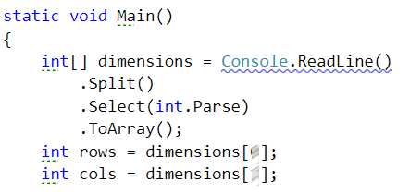
Now we need to define a structure that will hold our array and fill it with values.
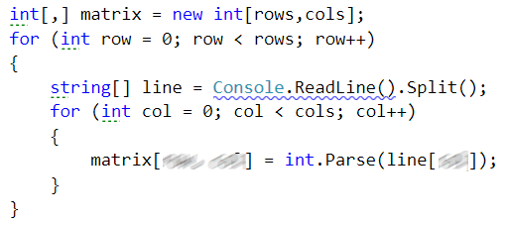
Last thing that left to read from the input is the location of the target cell.
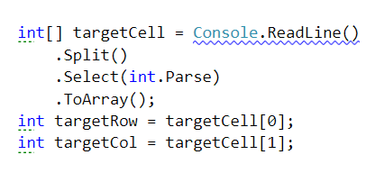
Calculate Sum of Neighbor Cells
We need set start and end indexes for the rows and cols for target cell neighbors
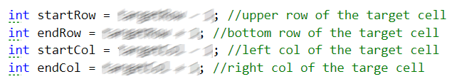
No we should find the sum of the neighbors of the target cell.
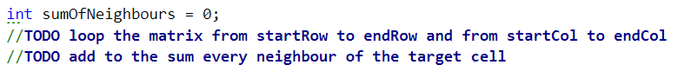
Change Value of Target Cell and Its Neighbors
Now we need to keep the original value of the target cell
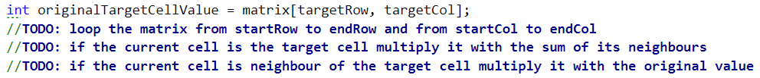
Print Result
Finally, we print the matrix.
